**A novel big data-driven framework for root cause analysis of in-line defects through Auto-Diagnostic**

Siqi Zhou, *Fab 10 Data Science Engineer,* Si Min Wong, *Fab 10 PIE RDA Engineer,* Peng Tan, *Fab 10 Data Science Manager,* Vincent Hong*, Fab 10 Data Science Senior Manager,* and Wi Hoong Lim*, Fab 10 PIE RDA Manager*

*Abstract:* During wafer fabrication, the large volume of data related to process steps, equipment, and lot history are stored in databases for subsequent process monitoring and diagnosing potential faults. These data are pertinent in root-cause tracking when anomalies exist during the manufacturing process. However, root-cause tracking is often not a straightforward task as a variety of factors might be interrelated, and especially in the conventional troubleshooting process, it involves a lot of manual work and often requires the engineers’ personal experience and domain knowledge. This paper presents a novel big data-driven framework of root cause analysis method through Auto-Diagnostic (AD). The Auto-Diagnostic framework consists of 3 innovative functionalities: an efficient way of data manipulation to form useful data frames for correlation results of all the potential root causes; an integrated system based on the special domain knowledge to provide the analysis that is close to real-time and daily diagnostic reports; a meaningful feedback system to train the whole framework using past lessons provided by subject matter experts. This approach has been validated to detect root causes of excursion with a stable accuracy of 70%. It has captured 16 win cases in recent 6 months and 80% of wins are from extremely tough cases with more than 800 steps and nearly impossible for engineers to troubleshoot.

*Index Terms:* Auto-Diagnostic, diagnostic, root cause, analysis

# Introduction

Semiconductor manufacturing is one of the most complex manufacturing systems that contain hundreds to thousands of process steps. Economies of speed are critical as semiconductor products in consumer electronics era compete with increasingly shortening time-to-market [1]. The quality requirement becomes stricter year by year, and at the same time, the lifecycle of a single product is getting shorter. Therefore, process stability is critical for products that run with mass production and it has a large impact on company earnings.

Historically, Statistical Process Control (SPC) charts have been an indispensable statistical tool to help in the timely process monitoring and detection of the out-of-control (OOC) event due to deviation in a process or equipment. It is a plot of the data over time with three additional lines: the center line (usually the mean) and upper and lower control limits (UCL and LCL) [2], as shown in Fig. 1. If a data point falls outside the control limits as an OOC point, the process is said to be out-of-control and that an investigation is warranted to find and remove the causes. In semiconductor manufacturing, the SPC data consists mainly of in-line measurements readings collected from wafers during and after the completion of the process step.

Although SPC is helpful in detecting process drifts, there is a significant delay between the occurrence of drift and the resulting control chart violation. As production volume increases, faster response to process drift becomes necessary in order to assure high product quality and low cost. As such, rapid root cause analysis for an OOC event become significantly important to identify the source of problems and generate solutions.

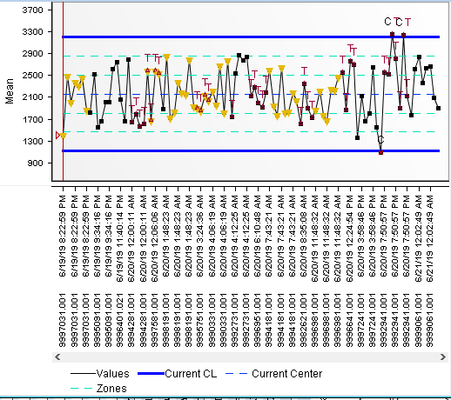

Fig. 1. An SPC chart example with UCL and LCL.

Currently, in Micron’s front-end fabs, PEE and RDA shift engineers are using Electronic Corrective Action Plan (eCAP) to response to SPC violations and monitor the in-line defects’ performance. Upon the OOC event triggered by eCAP alert, engineers have to diagnose the OOC chart by checking on the chart’s trend, extract the related defect metric and processing information, and then performing the commonality check for the OOC wafers. The current diagnosis practice has a few disadvantages:

* Poor effectiveness. Engineers need to manually select the related metrics and processing data to retrieve from the database. After that, engineers need to screen through all the plots to find out the source of the problem. The process is rather manual, subject to individual experiences and domain knowledge to detect the root cause, and thus highly prone to delay in reaction.
* Poor efficiency. The process is relatively time and resource consuming. Engineers need to know what are the parameters required at the start, because if there has any parameter missed out or required to extend the levels of troubleshooting, then will need to re-query the data again. Besides that, the time taken to diagnose a chart can be even longer when the data required to retrieve and analyze is huge or the analyzing software is hanged. Moreover, the process of advanced nanotechnology nodes becomes increasingly complicated to make the root cause tracking exponentially difficult and often not a straightforward task.

In this paper, we present an advanced big data-driven framework called Auto-Diagnostic (AD) to provide automated root cause analysis for OOCs in SPC charts to arrive the potential root causes of deviation. OOC charts are first filtered by a few criteria based on our triggering rule, then an innovative way of data manipulation is used to form useful data frames for correlation results of all the potential root causes. The whole analytics also includes domain knowledge checking and feedback system to train AD using past learned lessons provided by subject matter experts, etc. Upon completed the diagnosis, AD will generate meaningful reports to tabulate the potential root causes with plots and tables for illustration.

A detailed methodology is explained and discussed in the later sections to better illustrate the usefulness of the proposed approach. Section II explains the detailed flow and logic in AD. Section III proposes how to maintain important data libraries to support further data modeling and root cause analysis. Section IV presents the system architecture of the entire end-to-end application in Hadoop. Section V discusses the root cause analysis results and wins. Finally, our conclusion and future research directions are presented in Section VI.

# Methodology

Our approach first judges OOC charts and will only process further root cause analysis for those charts satisfied a few criteria set in our triggering rule, then applies data manipulation and the whole analytics with 2 rounds of ranking including domain knowledge checking, past learned lessons provided by subject matter experts, time-weighted correlation and curve trending detection to reduce false alarms, etc.

## Triggering Rule

As mentioned earlier, OOC charts are set upper control limits (UCL) and lower control limits (LCL). And those points beyond UCL or LCL are considered as OOC points inside the charts. To analyze a chart, it makes sense that this chart should have a minimum of 1 point within 24 hours and a minimum of 2 OOC points and 2 normal points in last 30 days since the whole analysis needs enough sample data to perform and narrow down the final potential root causes of OOC points.

## Data Manipulation

The root causes of OOC points are possible to come from process equipment highly due to preventive maintenance (PM) and corrective maintenance (CM), process chambers, recipes, special work request (SWR), quality deviation report (QDR), lot attributes, reticle and resist during the photo process steps, etc. Since root cause resources are numerous and the data structures are increasingly complicated, an efficient approach is proposed to form a time-saving dataframe for nearly real-time root cause detection. A staging example of QDR dataset is shown in Table I. Different root cause datasets might have minor difference but with almost the same format as follows,

Table I  
QDR Dataset Example

|  |  |  |  |
| --- | --- | --- | --- |
| lot ID | wafer ID | QDR | Affected Step |
| 9395201.001 | NA | No | 4200-28 WO ARC DEP, 4610-28 W1 MLR COAT, 3010-63 VIA PHOTO, 3010-6B VIA PHOTO, 4610-29 W2 MLR COAT |
| 9395201.001 | 5201-21 | No | 4610-29 W2 MLR COAT, 3010-22 PILLAR PHOTO |
| 9354791.001 | NA | Yes | 5030-55 BL AG OXIDE DRY ETCH, 3010-44 METCON PHOTO |
| 9354791.001 | 4791-09 | Yes | 5030-55 BL AG OXIDE DRY ETCH |

Data manipulation first queries all the potential root causes based on categories and merge them together with step name from different datasets and then form an efficient data frame.

First, a data ETL (extract, transform, load) step is invoked to query all the potential root causes as mentioned earlier and OOC chart data together. Then the root causes of different categories including lot/wafer IDs and the potential root cause itself are formed as vertical columns one by one, as shown in Table II. At the same time, lot and wafer IDs, measurement steps and process steps are tied to all the points in OOC charts. Such information is organized as another 3 columns (Table III). Finally, two sub-dataframes are inner joint together based on the same lot/wafer IDs, as depicted in Table IV. Root cause 1 has higher possibility to be the real root cause because of the higher correlation and the exact same trend variation with Column OOC.

Table II  
Dataframe Example of Potential Root Causes

|  |  |  |  |
| --- | --- | --- | --- |
| lot ID | wafer ID | Root cause 1 | Root cause 2 |
| lot 1 | wafer 1 | 0 | 1 |
| lot 2 | wafer 2 | 1 | 1 |
| lot 3 | wafer 3 | 0 | 1 |
| lot 4 | wafer 4 | 1 | 0 |
| lot 5 | wafer 5 | 0 | 0 |
| lot 6 | wafer 6 | 1 | 0 |

Table III  
Dataframe Example of OOC charts

|  |  |  |
| --- | --- | --- |
| lot ID | wafer ID | OOC |
| lot 1 | wafer 1 | 0 |
| lot 2 | wafer 2 | 1 |
| lot 3 | wafer 3 | 0 |
| lot 4 | wafer 4 | 1 |
| lot 5 | wafer 5 | 0 |
| lot 6 | wafer 6 | 1 |

Table IV  
Final Dataframe Example after Data ETL

|  |  |  |  |  |
| --- | --- | --- | --- | --- |
| lot ID | wafer ID | OOC | Root cause 1 | Root cause 2 |
| lot 1 | wafer 1 | 0 | 0 | 1 |
| lot 2 | wafer 2 | 1 | 1 | 1 |
| lot 3 | wafer 3 | 0 | 0 | 1 |
| lot 4 | wafer 4 | 1 | 1 | 0 |
| lot 5 | wafer 5 | 0 | 0 | 0 |
| lot 6 | wafer 6 | 1 | 1 | 0 |

## The 1st Round of Ranking

The core idea is to rank all the columns representing all the potential root causes and select the most possible ones according to the correlation results. However, it is totally not enough if only relying on correlation values. We invoke several innovative ideas to make the rank number more accurate such as adding time-weighted correlation, domain knowledge checking, past learned lessons, and PM/CM checking to boost up the confidence of process equipment as real root causes.

### Time-weighted correlation

Time-weighted correlation defines the recent OOC points to have higher possibilities and weights to contribute to the rankings, which is also a common sense for shift engineers’ manual diagnostic. Rank numbers are calculated like regular correlation but with using weighted means based on time series. Weighted means can be calculated as in (1),

$m_{X}=\frac{\sum_{i}{w_{i}x_{i}}}{\sum_{i}{w_{i}}}, m_{Y}=\frac{\sum_{i}{w_{i}y_{i}}}{\sum_{i}{w_{i}}},$ (1)

### Domain knowledge checking

PEE and RDA shift engineers usually have their own domain knowledge based on individual troubleshooting experiences. For example, resist fails defects whereby the pattern is distorted, normally they will first suspect the photo or dry etch area.

There is a domain knowledge library including defect parameter, process step keywords, and corresponding suspicious loop range. Domain knowledge is converted as configuration settings in the source code to narrow down the suspicious steps. A config example shows as follows: if the defect parameter of OOC charts is CB_19_RESIDUE, current loop after PHOTO steps is with higher chance causing OOC. “ge” means greater and equal.

“CB_19_RESIDUE”: {

“step_key_words”: “PHOTO$”,

“mode”: “ge”,

“loop_range”: “at_loop”}

### Past learned lessons

AD will generate reports and embed report links in a dashboard for users’ access and feedback collection. All the feedback will be stored in MSSQL. AD will query past feedback from MSSQL database of the same OOC chart and mark it in a report this time if available to avoid the wrong diagnostic repeatedly and remind users past root causes. A historical feedback example is shown in Table V.

Table V  
Historical Feedback Example in AD report

|  |  |  |  |  |
| --- | --- | --- | --- | --- |
| channel ID | session ID | actual root cause step | actual root cause type | actual root cause |
| 235996_0 | 2019-04-28 | 3010-27 HV PHOTO | equipment id | PHVT7A7200 |
| 235996_0 | 2019-04-27 | 5030-27 HV NITRIDE DRY ETCH | process chamber id | APXT7A68C0 |

### PM/CM checking

PM/CM checking is aimed to correlate OOC points and the lead lot after PM/CM to boost up the confidence on root cause findings since the first two lots got higher possibilities causing deviation after the equipment maintenance. The checking criteria are to use last OOC lot and check whether it is under the first two lots after certain PM/CM and certain step. For instance, we assume that such a dataframe is obtained after invoking PM/CM checking logic shown in Table VI. By given equipment id as APXTAABE00 and step as 5030-58 CHOP INSITU DRY ETCH, the first lead lot ID is 9335591.001, the 2nd lead lot is 9500431.001.

Table VI  
PM/CM Checking Dataframe Example

|  |  |  |  |  |
| --- | --- | --- | --- | --- |
| equipment ID | context/lot ID | datetime | step name | ranking |
| APXTAABE00 | WAIT_REPAIR | 2018-10-14 15:46:00 | null | 7 |
| APXTAABE00 | 9546341.001 | 2018-10-14 17:56:00 | 5030-08 ALIGN MARK INSITU DRY ETCH | 8 |
| APXTAABE00 | 9335591.001 | 2018-10-14 18:28:40 | 5030-58 CHOP INSITU DRY ETCH | 9 |
| APXTAABE00 | 9500431.001 | 2018-10-14 20:44:40 | 5030-58 CHOP INSITU DRY ETCH | 10 |

## The 2nd Round of Ranking

Although the 1st round of ranking does perform absolutely good accuracy, sometimes AD highlights obviously not true root causes due to a similar curve trend of commonality checking in reports. The 2nd round of ranking helps reduce false alarms.

Assume a lot is going through hundreds of steps as shown in Fig. 2 and Tool B in Step 2 got issues inside causing deviation and OOC points in SPC chart when monitoring. Then the plotting trend of Tool A should be with a smooth curve and small variance and by contrast, Tool B’s curve should have the trend beyond UCL or LCL and hit most of OOC points as depicted in Fig. 3.

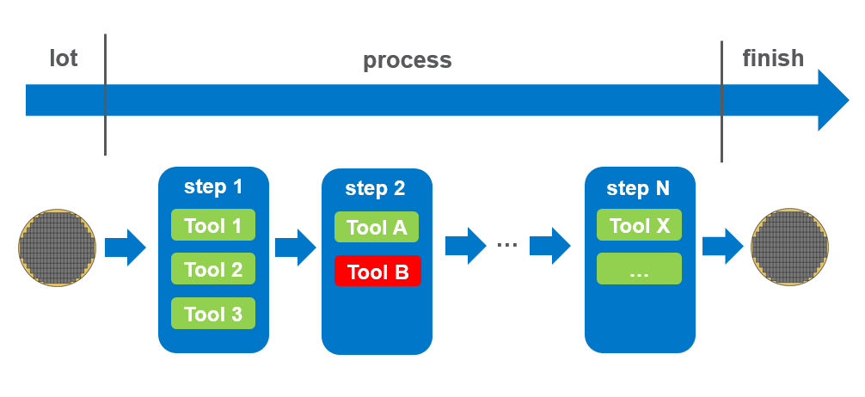

Fig. 2. Example of a lot processing structure.

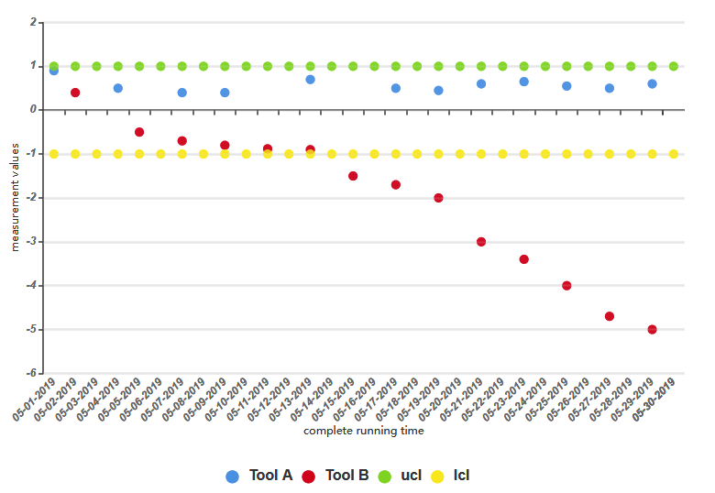

Fig. 3. Trend comparison between Tool A and Tool B.

A typical false alarm case is depicted in Fig. 4. The red points represent the measurement values of root cause diagnosed by AD and the blue points represent another tool in the same step as Tool 1. Even Tool 1 obtained very high correlation values after the 1st round of ranking, it is a truly false alarm case since the plotting results of Tool 1 and Tool 2 are with a very similar trend in this process step meaning that there must be other tools from other steps causing the drifting trend and OOC points beyond LCL.

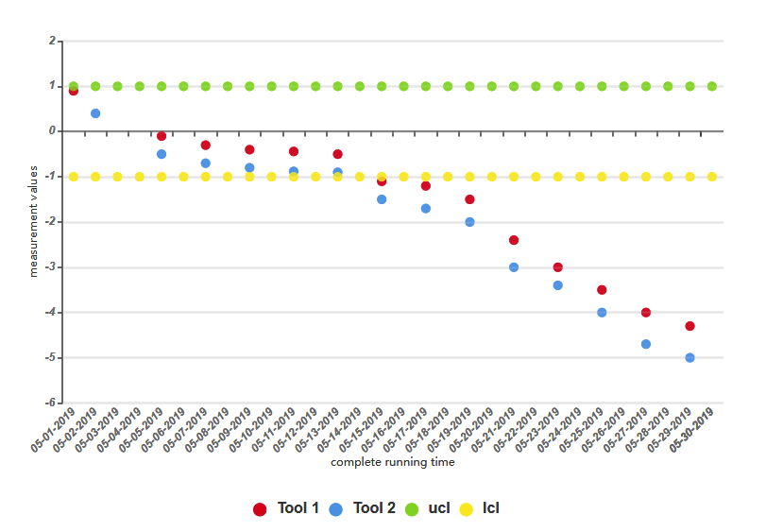

Fig. 4. A false alarm example.

Curve trend detection is invoked to filter out cases with a similar trend of plotting results in terms of the same step. We totally proposed 3 solutions of t-test, ARIMA and linear regression under scikit-learn and the final decision is to use linear regression. Based on the testing results, t-test only describes the variance of two different datasets using p-value which is not enough to determine the curve trending and it is not sensitive to time series analysis; ARIMA is good at time series forecasting but it will catch too detailed trend information, auto-tuning the parameters (p,d,q) also might pose a threat to the running time.

standing for the number of autoregressive terms, the number of nonseasonal differences needed for stationarity, and the number of lagged forecast errors in the prediction equation.

# Data Libraries

RDA and PEE provide a domain knowledge library containing the defect parameters and the corresponding process step pattern. With defect parameter obtained from OOC charts, the library can be searched and then narrows down the suspicious steps to reduce the analysis time. This domain knowledge library serves a key role in AD and greatly improve overall accuracy and performance.

There is another library called Past Lesson Learnt Library stored in MSSQL to track all the feedback from RDA and PEE engineers. We maintain this library not only for avoiding the wrong diagnostic repeatedly and reminding users past root causes in terms of the same chart, but also build a golden dataset for future analysis enhancement and algorithm improvement.

# AD as a Big Data Application

AD currently is embedded in an end-to-end big data application. Refer to Fig. 5 for the system overview of the entire application.

The application is executed on a big data system named Hadoop. It includes ingesting raw datasets from Hive, Teradata and HBase, data ETL to form efficient data frames and root cause analysis to select the most possible ones based on ranking numbers and correlation results.

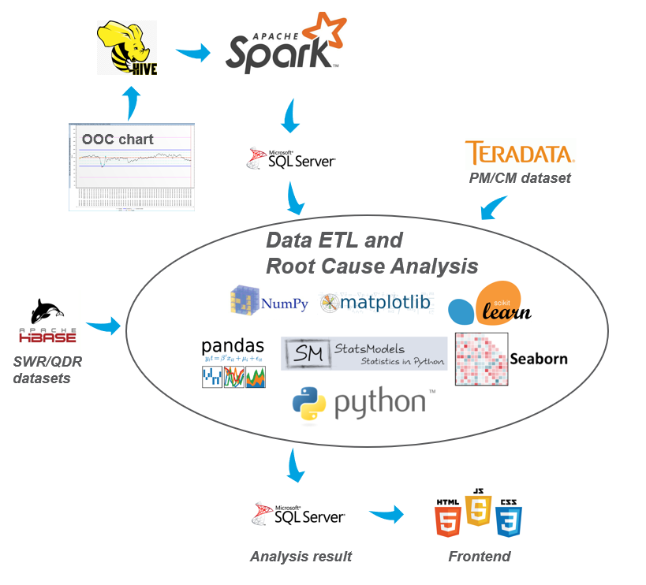

Fig. 5. The system architecture of AD as a Big Data Application.

# Results and Win Cases

AD has been fully deployed in Fab 10 in the mid-July of 2018 with a tableau dashboard setup for RDA and PEE users to view frontend reports. In the same year, AD was deployed and integrated into the eCAP system in November of 2018 to provide a nearly real-time root cause analysis.

AD is used to diagnose all PEE charts and RDA review charts. In recent 6 months, 16 win cases have been reported in F10, among which, AD was able to pinpoint to the correct root cause with the analysis from lot start to hit step covered the machine, recipe, lot attribute, Special Work Request (SWR) and Quality Deviation Report (QDR) information. 80% of wins are from extremely tough cases with more than 800 steps and nearly impossible for humans to troubleshoot. The win cases are listed in Table VII.

Table VII  
Auto-Diagnostic Win Cases

|  |  |  |
| --- | --- | --- |
| Step Name | Metric | Root Cause |
| B16A 3010-28 W0 PHOTO | CD1_LINE_BOT | 1210-28 W0 PHOTO SEM CD – AV417BS400 |
| B16A 1220-21 PILLAR INTEGRATED DRY STRIP CLN SCATTER | OCD | 3010-21 PILLAR PHOTO – PHVTAC4200 |
| N28A 1220-22 SGDP PRE POLY DEP 4 SCATTER | DEPTH_ARRAY_OXIDE_EDGE | 4110-22 DHC POLY DEP – ZPIQMLMPBGM1OPOP |
| N18A 5200-59 PERIPH OXIDE CMP | THK_STACK_ARRAY_EDGE_WAVGL | 5200-22 PILLA OXIDE BUFF CMP - QDR 66060610 |
| B27A 1230-29 W2 METAL CMP THK | DELTA_THK_OXIDE_NAAA | 5200-2B W1 METAL CMP – ZCMC2BSP300XGIII |
| N18A 1200-41 BITCON PHOTO REG | REG_Y | 3010-22 PILLAR PHOTO – PHVTAVQL00 |
| N18A 1230-22 PILLAR POLY DEP 2 THK | THK_POLY_NAAA_WAVGL | 4110-22 PILLAR NITRIDE DEP 3 – KTRGAVJJ00 |
| B17A 1250-21 PILLAR POLY WET ETCH WEIGHT | DELTA_MASS_WAVGL | 4200-21 PILLAR INSITU DEP – OPPRAD7600 |
| B16A 1210-52 WL INSITU DRY STRIP CLN SEM CD | CD2_TIERSTOTIERS | 3010-52 WL PHOTO -B16A_52_WL_PHOTO_WLMRRC_RETARGET |
| B16A 1210-57 CHOP INSITU DRY STRIP CLN SEM CD | CD3_57+54_EDGE_BOT_PULLBACK | B16A 57 CHOP PHOTO F15RECIPE_PRETARGET |
| N18A 1250-21 PILLAR POLY WET ETCH WEIGHT | DELTA_MASS_WAVGL | SWR 4285910 |
| 8120-PV PST THK AL-FLM1 MEA | REFLECTIVITY_AL | 8120-PV PST THK AL-FLM1 MEA - KSFXA28200 |
| B16A 1500-53 PERIPH OXIDATION EBEAM REVIEW | CB_42_VOID | 4300-53 PERIPH WSIX SPUTTER – MMENAA1800 |
| N18A 1500-55 BL METAL CMP EBEAM REVIEW | CB_51_BLOCKED_ETCH | 4200-55 BL CARBON DEP – TCVXATAP30 |
| B27B 1500-21 DHC POLY CMP EBEAM REVIEW | CB_33_CMP_SCRATCH | 5200-45 SL OXIDE CMP – recipe B27B_45SL_OXIDE_22 |
| B17A 1500-24 SGDP INSITU DRYSTRIP CLN EBEAM REVIEW | CB_36_HOLES | 4200-24 SGDP CARBON DEP -TCPRAREF00 |

Besides that, a tableau dashboard was set up to track the weekly AD’s performance. There are many improvements and enhancement work along the way to boost the diagnostic accuracy and user-friendliness, such as quantile check removal, domain knowledge checking and a feedback system to avoid past wrong diagnostic cases happened repeatedly. Based on available records from the dashboard, AD has been improved a lot and validated to detect root causes of excursion with a stable accuracy of 70%, as shown in Fig. 1.

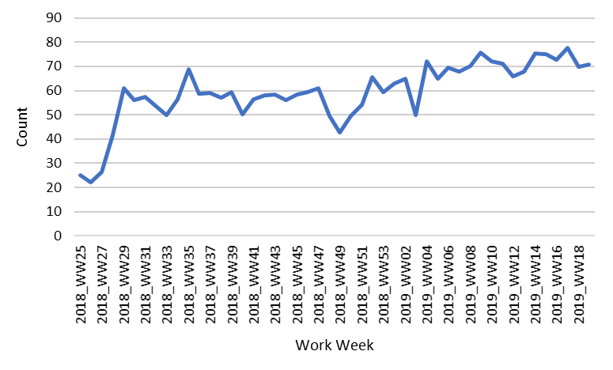

Fig. 1. Auto-Diagnostic accuracy from 2018-2019.

# Conclusion and Future Work

Root cause analysis has been part of RDA and PEE engineers’ daily routine work to monitor and improve process performance. In order to assure high product quality and low cost, a faster reaction to identify the source of problems and generate solutions for root causes of deviation becomes extremely important as production volume increases. However, there has been no systematic way for root cause analysis of OOC points in SPC charts effectively and efficiently.

With the introduction of the big data application Auto-Diagnostic (AD) consisting of 3 innovative functionalities of an efficient way of data manipulation to form useful data frames for correlation results of all the potential root causes, an integrated system based on the special domain knowledge to provide the analysis that is close to real-time and daily diagnostic reports as well as a meaningful feedback system to train the whole framework using past lessons provided by subject matter experts, the troubleshooting efficiency of OOC charts has been improved a lot resulting in production yield improvement and man-hour saving. Usually, AD can assist those shift engineers to arrive at potential root causes within 20 mins instead of 4 hours by manual checking. This approach has been validated to detect root causes of excursion with a stable accuracy of 70%. It has captured 16 win cases in recent 6 months and 80% of wins are from extremely tough cases with more than 800 steps and nearly impossible for engineers to troubleshoot.

Future work includes worldwide fan-out deployment, machine learning using analysis result library to further improve the accuracy and more meaningful root cause diagnostics, data latency shortening and analysis time optimization.

Acknowledgment

The authors thank the Fab 10 Data Science team for great innovation and valuable input as well as the Fab 10 RDA team for helping validate the data and results.

References

1. **Books:** C.-F. Chien, Y.-J. Chen, and J.-T. Peng, “Manufacturing intelligence

for semiconductor demand forecast based on technology diffusion and

product life cycle,” Int. J. Product. Econ., vol. 128, no. 2, pp. 496–509,

2010.

1. Minne, L., Eslami, S., de Keizer, N., de Jonge, E., de Rooij, S.E. and Abu-Hanna, A., “Statistical process control for validating a classification tree model for predicting mortality–a novel approach towards temporal validation”, *Journal of biomedical informatics*, vol. 45, Issue 1, pp.37-44, Feb 2012.

**S.Q. Zhou** received a master’s degree in Electrical and Electronics Engineering from Nanyang Technological University (Singapore) in 2017.

She started to work in Micron as a Data Science Engineer in 2018. She mainly focuses on projects about root cause analysis of in-line defects with a big data-driven framework through auto-diagnostic and automated mechanical scratch detection on the wafer map with cluster analysis and reinforcement using defect data.

**S.M. WONG** received a bachelor’s degree (with honors) in Material Science Engineering from University of Science Malaysia in 2016.

She joined Micron as a Real-Time Defect Analysis Engineer in 2016. She focuses on in-line excursion control.

**P.Tan** received a bachelor’s degree (with honors) in chemical engineering and an M.S. degree in statistics and applied probability from the National University of Singapore (Singapore) in 2011 and 2016, respectively.

He joined Micron Semiconductor Asia (Singapore) as a Process Control System Engineer and worked on the E3 R2R deployment and development in various areas. As the WET R2R leader, he contributed to Micron worldwide R2R alignment projects and supported the Fab 15 (Hiroshima, Japan) R2R initial setup. In 2016, he joined the Data Science team. He is currently the Data Science Manager in Fab 10 and focuses on projects about equipment predictive maintenance, auto diagnostics, and image analytics.

**V. Hong** received a B.Eng. degree (with honors) in electrical and electronics engineering from Nanyang Technological University (Singapore) in 2007.

He joined TECH as Test Application Engineer in Probe in 2007. He is one of the pioneers starting Big Data project at Micron in 2014 and currently works as the Data Science Senior Manager in Fab 10. He led a Big Data pilot project team to drive yield gain improvement through enabling the end user to data mine massive unstructured tool log and pioneer the introduction and usage of Spark in-Memory database analytics at Micron.

**W. H. Lim** received a master’s degree in materials science engineering from National University of Singapore in 2008.

She joined Micron in 2012 and is currently an RDA Process Manager.